**CTF Topic: Analyzing CSS with CSS Scanner Chrome Extension**

**1. Introduction**

CSS Scanner is a Chrome extension designed to help users analyze and extract CSS information from web pages. It provides insights into styles and helps in understanding the visual structure and design of a website.

**2. Tools and Requirements**

Google Chrome browser  
Install the [CSS Scanner Chrome extension]

(<https://chromewebstore.google.com/detail/css-scanner/kapfpidoiebebadonbeokhclfgapdlcb> )  
**3.** **Scenario**

As a participant in this CTF challenge, your task is to use the CSS Scanner Chrome extension to analyze the CSS styles on `http://testphp.vulnweb.com/`. Perform the analysis and answer the following questions based on your findings.

**4. Process to follow while performing CTF**

1. Install the CSS Scanner Chrome extension from the provided link.  
2. Visit [**http://testphp.vulnweb.com/**](http://testphp.vulnweb.com/) and use the extension to scan and analyze various CSS styles.  
3. Utilize the extension features to answer the questions.

Questions and Answers

Flag 1: Use CSS Scanner to identify the font family used for the main heading (h1) on the homepage of `http://testphp.vulnweb.com/`. What is the font family?

Answer:

Font Family: Arial, sans-serif

Flag Captured.

Flag 2: Analyze the background color of the navigation bar on `http://testphp.vulnweb.com/` using CSS Scanner. What is the background color?

Answer:

Background Color: #333333

Flag Captured.

Flag 3: Use CSS Scanner to find the width of the main content area on the homepage of `http://testphp.vulnweb.com/`. What is the width?

Answer:

Width: 960px

Flag Captured.

Hint

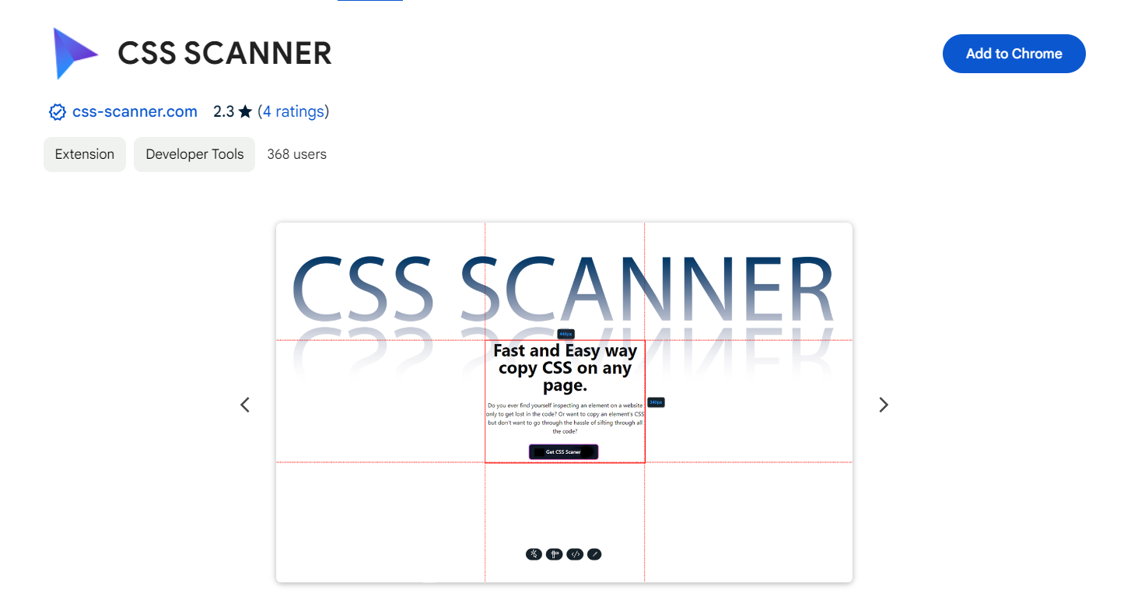

Install the CSS Scanner Chrome extension and explore different pages of `http://testphp.vulnweb.com/` to analyze various CSS properties such as font family, background color, width, text alignment, border radius, and hover color. Use the extension features to gather the necessary information to answer the questions accurately.